Alphabet Encodings and Formal languages
Prof. Dr. Raphael Volz
Hochschule Pforzheim
Table of Contents

Alphabets

Character-encoding schemes
- Interpretation function maps bit sequences to characters
- Function is a typically a bijective mapping table
- Example schemes:
  - ASCII (American Standard Code for Information Interchange)
  - Unicode (ISO 10646)
  - Latin 1 (ISO 8859-1)
- ASCII Example
  - Uppercase letter A
  - Decimal number 65
  - Binary 01000001

First 128 symbols in ASCII
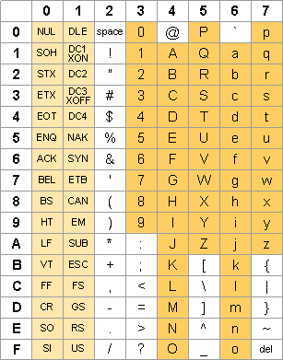
Source: ascii-table.com

Unicode Basic Multilingual Plane (BMP)
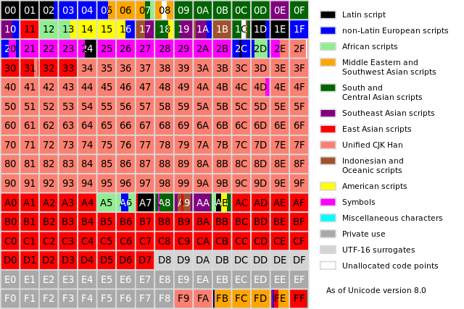
Source: Wikipedia
In the Unicode standard, a plane is a continuous group of 65,536 code points. There are 17 planes, identified by the numbers 0 to 16 decimal. The 17 planes can accommodate 1,114,112 code points, of which 2,048 are surrogates, 66 are non-characters, and 137,468 are reserved for private use, leaving 974,530 for public assignment.

Grammars

Formal languages
Exploration on the board. Learning questions:
- What is a terminal ?
- What is a non-terminal ?
- What constitutes a grammar ?
- What is meant by production rule ?

Avram Noam Chomsky
Father of modern linguistics (Professor emeritus MIT)
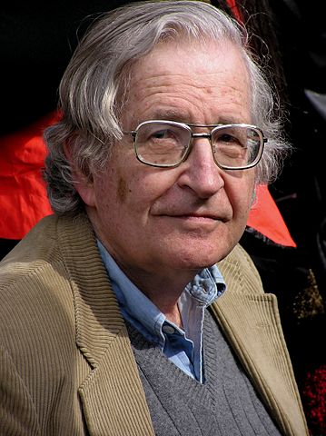
Noam Chomsky in 2004 by Duncan Rawlinson CC BY 2.0

Chomsky Hierarchy 101
Type | Name | Additional restrictions
0 | Phrase structure grammar | No restrictions on form of production rules
1 | Context-sensitive grammar | Left-hand side shorter than right-hand side for all production rules
2 | Context-free grammar | Left-hand side of production rule is only a variable (non-terminal)
3 | Regular grammar | Right-hand side of production rule is either a terminal or a terminal plus a variable

Computational complexity
Membership problem:
Given a set of data over $Σ$ does it belong to $L(G)$ ?
Type | Membership problem decidable | Complexity
0 | No | Undecidable
1 | Yes | exponential complexity (NP-hard)
2 | Yes | $O(n^{3})$
3 | Yes | $O(n)$ (linear complexity)

Recursion
- Production Rules can be recursive
- Recursion happens when variables appear (indirectly) on left and right-hand side of a production rule
- Often used in practice
- Example: Create a grammar for palindromes
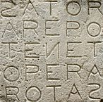
Photo by M Disdero - Taken at Oppede, Luberon, France - CC BY-SA 3.0

Movie: Grammar of happiness

EBNF

John Backus (1924 - 2007)
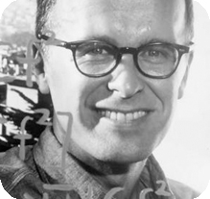
John Backus
Turing Award (1977)
For profound, influential, and lasting contributions to the design of practical high-level programming systems, notably through his work on FORTRAN, and for seminal publication of formal procedures for the specification of programming languages.

Peter Naur (1928 - 2016)
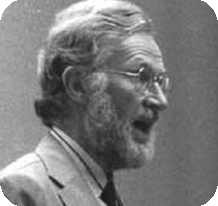
Peter Naur
Turing Award (2005)
For fundamental contributions to programming language design and the definition of Algol 60, to compiler design, and to the art and practice of computer programming.

EBNF - Extended Backus-Naur Form
Meta syntax (Meta language) for definition of context free grammars
- Definitions are inline of production rules
  - Terminal symbols (Alphabet)
  - Non-Terminal symbols (Variables)
- Standard: ISO/IEC 14977:1996(E)
- Extended by Niklaus Wirth (ETH) to create a formal definition of the computer language Pascal

EBNF Example
twelve = "1", "2";
non-zero-number = "1" | "2" | "3" | "4" | "5" | "6" | "7" | "8" | "9" ;
digit = "0" | non-zero-number ;
natural-number = non-zero-number, { Digit } ;
integer = "0" | [ "-" ], natural-number ;

EBNF symbols
Usage | Notation
definition | =
concatenation | ,
termination | ;
alternation | |
optional | [ ... ]
repetition | { ... }
grouping | ( ... )
terminal string | " ... " or ' ... '

Parsers

Parser
A parser is a computer program that
- performs lexical and syntactic analysis
- analyses whether data conforms to a formal grammar
- creates an object representation of the data that can be used within programs
- provides meaningful error messages and reporting
- is mostly generated from a grammar via generators
- is always part of compilers and interpreters that translate computer programs into executable binary code

JEG.js
Parser generator written in JavaScript
- Creates a parser program based on a grammar
- Metasyntax goes beyond EBNF
  - Embeds code fragments into production rules
  - Binds non-terminals in grammar to variables in code
  - Embedded code executed while processing data
- Generated parser is itself a JavaScript program
  - typically downloaded and embedded into own JavaScript programs (and Websites)
  - executed by the browser (or in other JS environments)

JEG.js example and exercise
- Example: Simple grammar for basic arithmetics
- Exercise: Change the grammar to allow division with remainder (modulo) using % notation

Student Evaluation

Please participate in the questionaire
Wird geladen...

